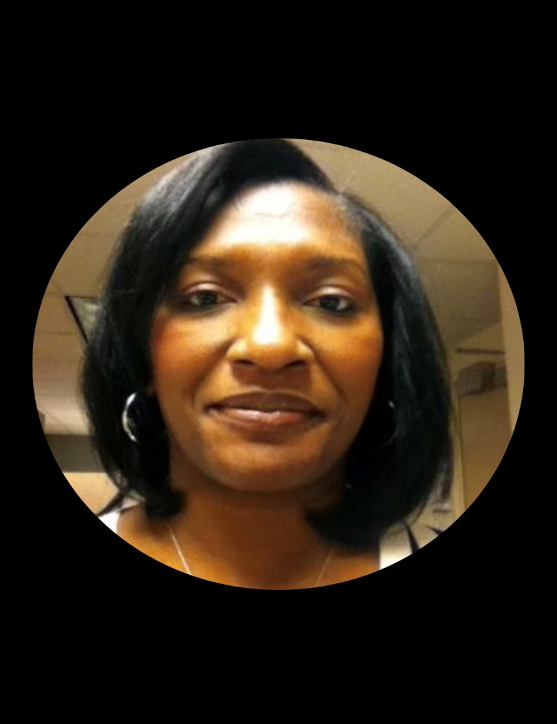

Created and operated by Jessielyn Cameron, CPA, a results-minded, dedicated individual with extensive experience in individual and small business taxes since 2015. Ms Cameron worked for three tax seasons with Intuit, Corp (Turbo Tax) as a Certified Tax Expert, providing guidance to thousands of clients on complex tax regulations. She also provides book-keeping and tax returns for individual/small business clients, and provides consulting services for small business and non-profit entities.

Ms Cameron also has accounting and financial management experience with the United States Government. From 1992 to 2015, Ms Cameron served in progressively responsible positions with US Forest Service and the US Army Assistant Secretary of Financial Management. She oversaw the quarterly/annual financial statement(s) compilation for the Army's General Fund and Working Capital Fund, managed the Internal Audit training program; conducted internal program audits as well as investigations into allegations of waste/fraud/abuse.

Ms Cameron held positions as a Legislative Staff member in the US Senate, Congressional Aide in US House of Representatives, and fourteen years as Supervisory Accountant with US Forest Service. She was integrally involved in the conversion and implementation of new financial accounting operating and reporting system in the Forest Service, which ultimately earned its first Unqualified Audit Opinion in history in 2002.

In addition to Bachelors in Accounting (Summa Cum Laude) from Alcorn State University, Ms Cameron possess a Masters in Business Administration (MBA) and an Executive Masters in Public Administration (EMPA) from Syracuse University. She holds an active license as a Certified Public Accountant (CPA), and certification(s) as a Certified Government Financial Manager (CGFM), and a Certified Defense Financial Manager (CDFM).

Through this collective experience and education, Ms Cameron possesses proven skills in partnership building, leading people and organizational management. She is confident that these skills, coupled with personal initiative, dedication and a committed work ethic would ensure that the doors of your wildest dreams are opened as wide as possible to as many as possible.